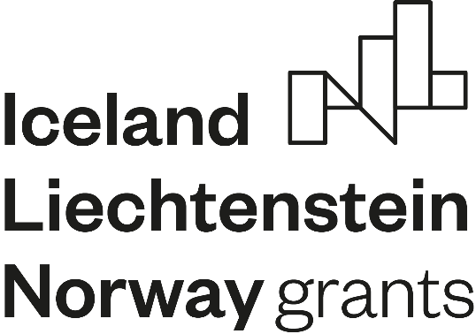

The Public Health Bureau of Klaipėda District Municipality together with partners – Klaipėda District Municipal Administration, the Public Health Bureau of Palanga City Municipality and Skuodas District Municipal Administration are implementing the Project LT03-2-SAM-K01-012 „Inclusive health education in a health-promoting environment“ funded under the “Health” Programme of the European Economic Area Financial Mechanism.
Providing health rooms in pre-primary and school education institutions with methodological tools to improve prevention and reduce health inequalities.

The Project aims to improve the prevention of health risks and reduce health inequalities in pre-primary and school education institutions in Klaipėda County.
It is very important to carry out preventive work at a younger age, when children and young people are more responsive and develop their habits, which inter alia they can also pass on to their environment and to the adults around them. It is important to do this work in a way that is attractive and engaging for children and young people. In order to ensure the smooth performance and continuity of this activity, the appropriate environment and infrastructure are needed – the means to enable the educational function and to promote the prevention in an appropriate and attractive way and using innovative methods. It would also enable health professionals working with the acquired tools to better identify health concerns of children and help them.
Investments in healthcare promote healthy lifestyle and minimise the risk of future diseases. In Klaipėda district, 9 rooms will be renovated and 20 rooms will be equipped with methodological tools. Together with partners, a total of 15 health classrooms will be renovated and 39 classrooms will be equipped with methodological tools.

Palanga
Using funds of the Project “Inclusive health education in a health-promoting environment” in Palanga City Municipality, 3 health rooms have already been refurbished and 4 upgraded and public health specialists are now providing public health services there.
The workstations in the health care rooms have been upgraded with new furniture (tables, chairs, cabinets), couches, multifunction printers and mobile phones. The Project funds are earmarked for purchase of a total of more than 1,000 pieces of equipment and methodological tools necessary for the implementation of preventive work and for the proper provision of the health rooms. Most of the methodological tools are intended for strengthening of mental health and prevention of addictions, and some of them have already been purchased and will soon reach educational institutions of Palanga City Municipality. At least 220 pupils attending educational institutions of Palanga City Municipality will benefit from the services in the renovated and improved rooms. The total number of pupils attending educational institutions in Palanga City Municipality is 2,789 (as of 1 September 2021).
The Project outcomes will directly contribute to improving prevention and reducing health inequalities and will more effectively enhance the physical and mental well-being of children and young people in the municipality. The health rooms in pre-primary and school education institutions, which have been renovated and supplied with equipment as part of the Project, will continue to operate after its implementation and the achievement of the Project goals and the provision of quality health services to children and young people will therefore continue.

Skuodas
Using funds of the Project “Inclusive health education in a health-promoting environment” in Skuodas District Municipality 3 health rooms have been renovated and public health specialists are already providing public health services there. The health services are available in Ylakiai nursery-kindergarten, Mosėdis nursery-kindergarten and Ylakiai gymnasium.
Health rooms have been supplemented and refurbished with new equipment:
Purchased equipment:
Magnetic mats, 2 pcs.
Interactive floors, 3 pcs.
Office chairs, 6 pcs.
Visitor chairs, 6 pcs.
Couches, 2 pcs.

Equipment currently being acquired:
Sound meter, 1 pc and Air quality meter, 1 pc.
Furniture – lockable wardrobe for clothes; lockable cabinet for work tools; lockable chest of drawers for work tools.
Electric adjustable desk, 2 pcs.

Klaipeda district

In Klaipėda district, 9 healthcare rooms have already been renovated and will soon be used by public health specialists to provide public health services.
During the Project, the following computer equipment was acquired for improving the quality and productivity of work: 20 mobile phones, 13 laptops, 18 printers, 100 tablets, 10 mini-speakers, video cameras with microphones, 4 interactive floor systems, in order to enhance and integrate healthy lifestyle activities into the general education curriculum.

