28th April 2022

To International Organisations

Support to Ukrainian Agriculture

Following the request by the Minister for donor support to agriculture, ( through a letter distributed at the last donor coordination meeting) we have agreed with MAPF to assist them (at their request) with identifying all donor agri-support as delivered to Ukraine and to prepare regular monitoring data on its distribution.
The coordinator for collecting this information will be Yuriy Zmiy ymzmiy@gmail.com working as part of the agriculture expert group and supporting the Ministry of Agrarian Policy and Food of Ukraine.
He may contact you directly but in the meantime it would also be very useful if you were able to provide him with any information you have on the aid you have provided so far, or will provide in the future.
We would appreciate your support in collecting this information. If you have any questions I will be happy to try and answer them
My best regards

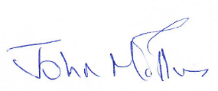

Team Leader
EU IPRSA Project

